Laboratory work #4

Please write SQL queries for following tasks and save as .sql file.

1. Create database called «lab_4»
2. Create following tables «Warehouses» and «Packs»:

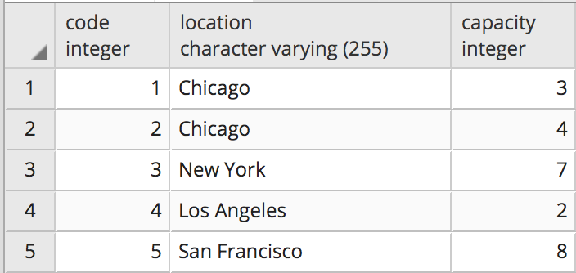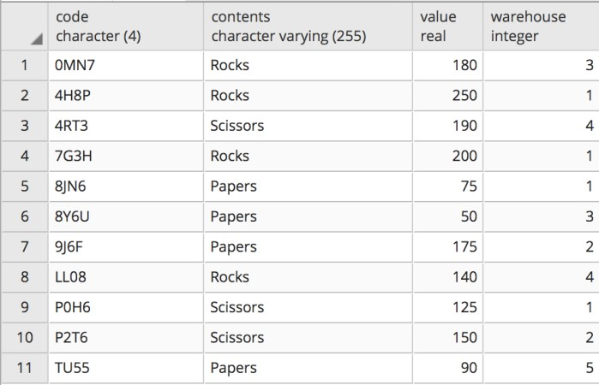

1. Download lab5.sql file from wsp.kbtu.kz Copy content of the file and run using Query Tool (check if tables created)
2. Select all packs with all columns.
3. Select all packs with a value larger than $190.
4. Select all the packs distinct by contents.
5. Select the warehouse code and the number of the packs in each warehouse.
6. Same as previous exercise,but select only those warehouses where the number of the packs is greater than 2.
7. Create a new warehouse in Texas with a capacity for 5packs.
8. Create a new pack, with code "H5RT", containing "Papers"with a value of $150, and located in warehouse 2.
9. Reduce the value of the third largest pack by 18%.
10. Remove all packs with a value lower than $150.
11. Remove all packs which is located in Chicago. Statementshould return all deleted data.